

MONITORING EV BATTERY MANAGEMENT SYSTEM USING IOT

A PROJECT REPORT

Submitted by
ABINAYA A (714221106002)
SHIBIN G (714221106040)
VIVETHA N (714221106045)
YASWANTH PRASANNA P (714221106305)

In partial fulfillment for the award of the degree
of
BACHELOR OF ENGINEERING
In
ELECTRONICS AND COMMUNICATION ENGINEERING

TAMILNADU COLLEGE OF ENGINEERING,
COIMBATORE

ANNA UNIVERSITY : CHENNAI 600 025

MAY 2025


MONITORING EV BATTERY MANAGEMENT SYSTEM USING IOT

A PROJECT REPORT

Submitted by
ABINAYA A (714221106002)
SHIBIN G (714221106040)
VIVETHA N (714221106045)
YASWANTH PRASANNA P (714221106305)

In partial fulfillment for the award of the degree
of
BACHELOR OF ENGINEERING
In
ELECTRONICS AND COMMUNICATION ENGINEERING

TAMILNADU COLLEGE OF ENGINEERING,
COIMBATORE

ANNA UNIVERSITY: CHENNAI 600 025

MAY 2025

BONAFIDE CERTIFICATE

Certified that this project work “MONITORING EV BATTERY MANAGEMENT SYSTEM USING IOT” is the bonafide work of ABINAYA A (714221106002), SHIBIN G (714221106040), VIVETHA N (714221106045), YASWANTH PRASANNA P (714221106305) who carried out the project work under my supervision.

SIGNATURE SIGNATURE
Mr. K. Ram Karthik Kumar., Mrs. N. Sowmiya.,
B. E., M. Tech., (Ph.D.,) M.E., B.A., DaF
HEAD OF THE DEPARTMENT SUPERVISOR
Assistant professor Assistant professor
Electronics and communication Electronics and communication
Engineering Engineering
Tamilnadu College Of Engineering Tamilnadu College Of Engineering
Coimbatore – 641 659. Coimbatore – 641 659.

Submitted for Viva-Voice Examination held on ……………..

INTERNAL EXAMINER EXTERNAL EXAMINER

ACKNOWLEDGEMENT

We express our deep sense of gratitude to the management for admitting us into this project.
We extend our sincere and wholehearted thanks to our beloved principal Dr. M. PRINCE and Director Dr. N. S. SAKTHIVEL MURUGAN for his continuous support in all our curricular activities.
We are tremendously thankful to our Head of the Department Mr. K. Ram Karthik Kumar., B.E., M. Tech., (Ph.D.,) for his encouragement and support.
We would like to off our wholehearted thanks to our Project Guide Mrs. Sowmiya N., M.E., B.A., DaF., for her continuous guidance, valuable suggestions and feedback for completing the project work successfully.
We extend our sincere thanks to all the teaching and non-teaching faculty members of the department for their assistance and all our friends who helped us in bringing out of our project in good shape and form.
We sincerely thank our beloved PARENTS for their encouragement and support in all endeavors.

ABSTRACT
The increasing global emphasis on sustainable transportation has accelerated the adoption of electric vehicles (EVs). Despite their environmental advantages, EVs face critical challenges in maintaining battery health and operational safety due to the lack of accessible and affordable monitoring systems. To address these concerns, this project proposes the design and implementation of an Electric Vehicle Monitoring System (EVMS) using the ESP32 microcontroller, integrated with voltage, current, and temperature sensors.
The system continuously monitors essential battery parameters and transmits real-time data to the Blynk IoT platform, enabling remote access and analysis. The EVMS enhances safety by incorporating a proactive temperature control mechanism that activates a cooling fan and buzzer when high temperature thresholds are exceeded, thereby preventing overheating and potential battery damage.
The proposed EVMS is a cost-effective, scalable, and user-friendly solution that utilizes open-source tools and commonly available components. It is compatible with various EV platforms and supports wireless connectivity, enabling both local and cloud-based monitoring. The system’s modular design facilitates easy deployment and integration into existing electric vehicle infrastructures.
Testing and validation confirm the system’s reliability and effectiveness in real-time monitoring and fault prevention. The project not only contributes to safer EV operation but also promotes broader adoption of electric mobility by offering an affordable monitoring alternative. Future improvements may include AI-based predictive diagnostics and expanded sensor integration to support advanced battery management systems.

TABLE OF CONTENTS

S.NO | TITLE | PAGE NO.
 | ABSTRACT | V
 | TABLE OF CONTENTS | VI
 | LIST OF TABLES  LIST OF FIGURES | VIII  IX
 | LIST OF ABBREVIATIONS | XI
1 | INTRODUCTION | 1
 | 1.1 PROBLEM STATEMENT | 2
2 | LITERATURE SURVEY | 3
 | 2.1 OBJECTIVES | 8
3 | EXISTING SYSTEM | 10
 | 3.1 EXISTING SYSTEM DRAWBACKS | 10
 | 3.2 METHODOLOGY | 11
4 | PROPOSED SYSTEM | 12
 | 4.1 PROPOSED SYSTEM ADVANTAGES | 13
5 | HARDWARE AND SOFTWARE REQUIREMENTS | 16
 | 5.1 CIRCUIT DESCRIPTION | 17
 | 5.1.1 ESP32 MICROCONTROLLER | 17
 | 5.1.2 VOLTAGE SENSOR INTERFACE | 17
 | 5.1.3 CURRENT SENSOR INTERFACE | 18
 | 5.1.4 TEMPERATURE SENSOR INTERFACE | 18
 | 5.1.5 COOLING FAN AND BUZZER  CONTROL | 18
 | 5.1.6 WI-FI MODULE INTERFACE | 19
 | 5.1.7 POWER SUPPLY MANAGEMENT | 19
 | 5.2 HARDWARE REQUIREMENTS | 19
 | 5.2.1 AC-DC CONVERTOR | 20
 | 5.2.2 LEAD-ACID BATTERIES | 21
 | 5.2.3 POWER SUPPLY MODUL | 24
 | 5.2.4 RECTIFIER | 25
 | 5.2.5 RELAY | 27
 | 5.2.6 VOLTAGE SENSOR | 32
 | 5.2.7 CURRENT SENSOR | 32
 | 5.2.8 DHT 11 | 34
 | 5.2.9 BUZZER | 35
 | 5.2.10 COOLING SYSTEM | 37
 | 5.2.11 WI-FI MODULE ESP 01 | 39
 | 5.2.12 BLYNK | 41
6 | RESULTS AND APPLICATIONS | 43
 | 6.1 SOURCE CODE | 43
 | 6.2 HARDWARE OUTPUT | 51
 | 6.3 SOFTWARE OUTPUT | 52
 | APPLICATIONS | 53
7 | FUTURE SCOPE | 54
 | CONCLUSION | 54
 | REFERENCES | 55

LIST OF TABLES

CHAPTER  NO | TITLE | PAGE NO
1.1 | EV MONITORING PARAMETERS | 3
2.1 | COMPARACTIVE ANALYSIS OF EXISTING RESEARCH | 8
3.1 | EXISTING SYSTEM DRAWBACKS | 11
4.1 | PROPOSED SYSTEM ADVANTAGES | 14
5.1 | HARDWARE OVERVIEW | 17

LIST OF FIGURES

CHAPTER NO | TITLE | PAGE NO
4 | 4.2 BLOCK DIAGRAM | 15
5 | 5.1 LEAD-ACID BATTERY | 21
 | 5.2 5V/12V DC POWER SUPPLY MODULE | 24
 | 5.3 RECTIFIER | 25
 | 5.4 RELAY CIRCUIT DIAGRAM | 29
 | 5.5 RELAY CONTROLLED SWITCH | 30
 | 5.6 VOLTAGE SENSOR | 32
 | 5.7 CURRENT SENSOR | 33
 | 5.8 DHT11 TEMPERATURE & HUMIDITY SENSOR | 34
 | 5.9 DHT11 PINOUT | 35
 | 5.10 BUZZER | 36
 | 5.11 PASSIVE & ACTIVE BUZZER MODULE | 36
 | 5.12 COOLING SYSTEM | 38
 | 5.13 ESP32 ESP-01 | 40
 | 5.14 BLYNK APP | 41
6 | 6.1 HARDWARE OUTPUT | 51
 | 6.2 HARDWARE KIT | 51
 | 6.3 SOFWARE OUTPUT | 52

LIST OF ABBREVIATION
S. NO. | ACRONYMS | ABBREVIATION
1 | EV | Electric Vehicle
2 | BMS | Battery Management System
3 | IOT | Internet of Things
4 | LCD | Liquid Crystal Display
5 | ADC | Analog to Digital Converter
6 | DAC | Digital to Analog Converter
7 | PWM | Pulse Width Modulation
8 | UART | Universal Asynchronous Receiver Transmitter
9 | WI-FI | Wireless Fidelity
10 | GPIO | General Purpose Input Output
11 | SPI | Serial Peripheral Interface
12 | I2C | Inter-Integrated
13 | DC | Direct Current
14 | AC | Alternating Current
15 | RTC | Real Time Clock
16 | LED | Light Emitting Diode
17 | DHT | Digital Humidity
18 | ESP | Espressif (Wi-Fi Module Family Name)

CHAPTER 1
INTRODUCTION
The widespread adoption of electric vehicles (EVs) heralds a significant shift towards sustainable transportation, offering reduced emissions and decreased reliance on fossil fuels. As the EV industry continues to evolve, ensuring the safety, efficiency, and reliability of electric vehicle systems becomes paramount. Central to this endeavor is the effective monitoring of critical parameters such as battery voltage, current flow, and temperature levels. These parameters not only influence the performance and longevity of the vehicle's power source but also impact overall safety.
To address these concerns, we propose the development of an Electric Vehicle Monitoring System (EVMS) using readily available components such as ESP32 microcontroller, voltage sensor, current sensor, and temperature sensor. The EVMS aims to provide real-time monitoring of essential parameters while integrating with Thing Speak, an Internet of Things (IoT) platform, for data storage and remote access.
In this project, we seek to design a cost-effective, yet robust monitoring solution that can be easily deployed in electric vehicles of varying scales. The EVMS will continuously collect data from the sensors and transmit it to Thing Speak servers over the internet, enabling users to remotely monitor the health and performance of their electric vehicle systems.
Recognizing the importance of temperature control in EVs, our system incorporates mechanisms to mitigate overheating risks. By activating a fan and sounding a buzzer in response to high battery temperatures, the EVMS aims to prevent potential damage and ensure the safe operation of the vehicle.
Through the development and implementation of the proposed EVMS, we aim to contribute to the advancement of electric vehicle technology by enhancing safety, reliability, and efficiency, thus accelerating the transition towards a sustainable transportation ecosystem.
1.1 PROBLEM STATEMENT
Despite the growing popularity of electric vehicles (EVs), ensuring the safety and reliability of their electrical systems remains a critical challenge. Electric vehicle batteries, in particular, are sensitive to variations in voltage, current, and temperature, which can significantly impact their performance, longevity, and safety. Without effective monitoring and control mechanisms, EVs are susceptible to various risks, including overheating, battery degradation, and potential safety hazards.
Existing monitoring solutions for EVs often suffer from limitations such as high cost, complexity, and lack of accessibility. Many commercial monitoring systems are tailored for specific vehicle models or require proprietary hardware and software, making them impractical for widespread adoption. Furthermore, the absence of real-time monitoring capabilities and remote access hinders proactive maintenance and timely intervention, increasing the likelihood of critical failures and accidents.
Therefore, there is a pressing need for an affordable, scalable, and user-friendly Electric Vehicle Monitoring System (EVMS) that can provide comprehensive monitoring of essential parameters such as battery voltage, current, and temperature. Such a system should be capable of seamlessly integrating with existing EV architectures, enabling real-time data collection, analysis, and remote access.
Moreover, the EVMS should incorporate intelligent control mechanisms to mitigate potential risks, such as overheating, by activating cooling systems or alerting users to take corrective actions promptly. By addressing these challenges, the proposed EVMS aims to enhance the safety, reliability, and performance of electric vehicles, thereby accelerating their widespread adoption and contributing to a sustainable transportation future.
Parameter | Importance in EVs | Risk if Unmonitored
Voltage | Indicates battery charge status | Over-discharge, damage
Current | Reflects load and charging behavior | Overcurrent, overheating
Temperature | Shows thermal condition of battery | Fire, thermal runaway

Table 1.1 EV Monitoring Parameters

CHAPTER 2
LITERATURE SURVEY
Amarnath, M., Chitra, R., & Natarajan, V. (2020). Design and Development of an Electric Vehicle Monitoring System. International Journal of Advanced Trends in Computer Science and Engineering, 9(5), 6856-6862.
This paper presents the design and development of an Electric Vehicle Monitoring System (EVMS) aimed at enhancing the safety and performance of electric vehicles (EVs). The system incorporates various sensors to monitor critical parameters such as battery voltage, current, and temperature in real-time. Through the integration of Arduino microcontroller and IoT technology, data from these sensors are transmitted to a central monitoring unit for analysis and visualization. The EVMS enables remote access to vehicle data, facilitating proactive maintenance and timely intervention to prevent potential failures. The effectiveness of the system is demonstrated through comprehensive testing under different operating conditions, showcasing its potential for widespread adoption in the EV industry.
Zhang, Y., Lin, Y., & Li, K. (2021). Design of Electric Vehicle Monitoring System Based on Internet of Things. 4th International Conference on Electric Vehicle Technology (ICEVT).
This study presents the design and implementation of an Electric Vehicle Monitoring System (EVMS) leveraging Internet of Things (IoT) technology. The system integrates various sensors to monitor key parameters of electric vehicles, including battery status, temperature, and performance metrics. Through the utilization of IoT platforms, real-time data transmission and remote access to vehicle diagnostics are enabled, allowing for proactive maintenance and optimization of EV operations. The proposed EVMS offers scalability, interoperability, and cost-effectiveness, making it suitable for deployment across diverse electric vehicle fleets. Through experimentation and validation, the efficacy of the system in enhancing the safety, efficiency, and reliability of electric vehicles is demonstrated, paving the way for its adoption in the automotive industry.
Shrivastava, A., & Singh, P. (2020). Electric Vehicle Monitoring System. International Journal of Scientific & Technology Research, 9(8), 354-357.
This paper presents the development and evaluation of an Electric Vehicle Monitoring System (EVMS) designed to enhance the operational efficiency and safety of electric vehicles (EVs). The EVMS integrates advanced sensor technologies to monitor critical parameters such as battery voltage, current, and temperature in real-time. Leveraging the capabilities of Internet of Things (IoT) platforms, the system enables remote access and monitoring of vehicle data, facilitating proactive maintenance and timely intervention to prevent potential failures. Through comprehensive testing and validation, the effectiveness and reliability of the EVMS in enhancing the performance and safety of EVs are demonstrated, highlighting its potential for widespread adoption in the automotive industry.
Wang, S., Wang, X., & Li, W. (2021). Design of Electric Vehicle Monitoring System Based on IoT and Blockchain. IEEE Transactions on Industrial Informatics, 17(8), 5685-5693.
This paper proposes a novel design for an Electric Vehicle Monitoring System (EVMS) leveraging Internet of Things (IoT) and Blockchain technologies to enhance security and data integrity. The EVMS integrates various sensors to monitor crucial parameters of electric vehicles (EVs) in real-time, including battery status, temperature, and performance metrics. Through the utilization of IoT platforms, data from these sensors are transmitted securely to a central monitoring unit. Additionally, Blockchain technology is employed to ensure tamper-proof data storage and authentication, providing a secure and transparent framework for storing and accessing vehicle data. The proposed EVMS offers scalability, interoperability, and enhanced security, making it suitable for deployment across diverse electric vehicle fleets. Through experimentation and validation, the efficacy of the system in enhancing the security, efficiency, and reliability of electric vehicles is demonstrated, paving the way for its adoption in the automotive industry.
Chen, C., Liu, J., & Wang, Y. (2019). Development of Electric Vehicle Battery Monitoring System Based on IoT and Cloud Computing. 6th International Conference on Automation, Control and Robotics (ICACR).
This study presents the development and implementation of an Electric Vehicle Battery Monitoring System (EV-BMS) leveraging Internet of Things (IoT) and Cloud Computing technologies. The EV-BMS integrates various sensors to monitor key parameters of electric vehicle (EV) batteries in real-time, including voltage, current, and temperature. Through the utilization of IoT platforms and Cloud Computing services, data from these sensors are transmitted securely to cloud servers for storage and analysis. The proposed EV-BMS offers scalability, interoperability, and cost-effectiveness, making it suitable for deployment across diverse electric vehicle fleets. Through experimentation and validation, the efficacy of the system in enhancing the safety, efficiency, and reliability of electric vehicles is demonstrated, paving the way for its adoption in the automotive industry.
Li, X., Chen, L., & Wang, X. (2020). Research on Electric Vehicle State Monitoring System Based on IoT. International Conference on Electrical Engineering and Green Energy (CEEGE).
This paper presents research on the development of an Electric Vehicle State Monitoring System (EVMS) utilizing Internet of Things (IoT) technology. The EVMS integrates various sensors to monitor the state of electric vehicles (EVs) in real-time, including battery status, performance metrics, and environmental conditions. Through the utilization of IoT platforms, data from these sensors are transmitted securely to a central monitoring unit for analysis and visualization. The proposed EVMS offers scalability, interoperability, and cost-effectiveness, making it suitable for deployment across diverse electric vehicle fleets. Through experimentation and validation, the efficacy of the system in enhancing the safety, efficiency, and reliability of electric vehicles is demonstrated, paving the way for its adoption in the automotive industry.
Han, L., Wang, X., & Wang, Y. (2018). Design of Electric Vehicle Monitoring System Based on IoT. International Conference on Electrical Engineering and Control Technologies (ICEECT).
This study presents the design and implementation of an Electric Vehicle Monitoring System (EVMS) based on Internet of Things (IoT) technology. The EVMS integrates various sensors to monitor critical parameters of electric vehicles (EVs) in real-time, including battery status, temperature, and performance metrics. Through the utilization of IoT platforms, data from these sensors are transmitted securely to a central monitoring unit for analysis and visualization. The proposed EVMS offers scalability, interoperability, and cost-effectiveness, making it suitable for deployment across diverse electric vehicle fleets. Through experimentation and validation, the efficacy of the system in enhancing the safety, efficiency, and reliability of electric vehicles is demonstrated, paving the way for its adoption in the automotive industry.
Tang, J., Zhang, C., & Zuo, Y. (2019). Design and Implementation of Electric Vehicle Monitoring System Based on IoT. IEEE International Conference on Industrial Internet (ICII).
This paper presents the design and implementation of an Electric Vehicle Monitoring System (EVMS) leveraging Internet of Things (IoT) technology. The EVMS integrates various sensors to monitor key parameters of electric vehicles (EVs) in real-time, including battery status, temperature, and performance metrics. Through the utilization of IoT platforms, data from these sensors are transmitted securely to a central monitoring unit for analysis and visualization. The proposed EVMS offers scalability, interoperability, and cost-effectiveness, making it suitable for deployment across diverse electric vehicle fleets. Through experimentation and validation, the efficacy of the system in enhancing the safety, efficiency, and reliability of electric vehicles is demonstrated, paving the way for its adoption in the automotive industry.

Author(s) & Year | Technology Used | Focus Area | Key Outcome
Amarnath et al. (2020) | Arduino + IoT | Voltage, Current, Temp Monitoring | Real-time data with remote diagnostics
Zhang et al. (2021) | IoT Platform | Fleet Scalability | Scalable and interoperable system
Wang et al. (2021) | IoT + Blockchain | Security & Data Integrity | Tamper-proof EV data system
Chen et al. (2019) | IoT + Cloud Computing | Battery Diagnostics | Cloud-based analysis
Li et al. (2020) | IoT | EV State Monitoring | Enhanced reliability in real-time ops

Table 2.1 Comparative Analysis of Existing Research

2.1 OBJECTIVE
- Develop an Electric Vehicle Monitoring System (EVMS) using ESP32 and sensor modules.

- Integrate voltage, current, and temperature sensors to monitor key parameters of electric vehicle batteries.

- Implement real-time data transmission to Thing Speak IoT platform for remote monitoring and analysis.

- Incorporate temperature control mechanisms to mitigate overheating risks in electric vehicle batteries.

- Activate cooling systems and sound alerts (buzzer) in response to high battery temperatures.

- Design an affordable, scalable, and user-friendly monitoring solution for electric vehicles.

- Enhance safety, reliability, and performance of electric vehicle systems through proactive monitoring and control.

- Facilitate timely maintenance and intervention to prevent critical failures and accidents.

- Contribute to the advancement of sustainable transportation by promoting the adoption of electric vehicles.

CHAPTER 3
EXISTING SYSTEM
The existing systems for monitoring electric vehicles often entail various challenges and limitations. Many commercial solutions are tailored for specific vehicle models, leading to limited compatibility and scalability across different EV platforms. Additionally, these systems typically rely on proprietary hardware and software, resulting in high costs and limited accessibility for consumers and manufacturers alike. Moreover, the lack of real-time monitoring capabilities and remote access further impedes proactive maintenance and timely intervention. Without comprehensive monitoring of critical parameters such as battery voltage, current, and temperature, electric vehicles are susceptible to various risks, including overheating, battery degradation, and safety hazards. As a result, there is a clear need for an innovative and accessible Electric Vehicle Monitoring System (EVMS) that can address these challenges effectively while enhancing the safety, reliability, and performance of electric vehicles.

3.1 EXISTING SYSTEM DRAWBACKS
- Limited compatibility: Many systems are tailored for specific vehicle models, leading to compatibility issues across different EV platforms.
- High cost: Commercial solutions often entail high costs due to proprietary hardware and software, limiting accessibility for consumers and manufacturers.
- Lack of real-time monitoring: Existing systems often lack real-time monitoring capabilities, hindering proactive maintenance and timely intervention.
- Limited scalability: The scalability of current systems is restricted, making it challenging to implement across diverse electric vehicle fleets.
- Absence of remote access: The absence of remote access features prevents users from monitoring vehicle parameters and performing diagnostics from a distance, limiting convenience and efficiency.
Drawback | Description
Limited Compatibility | Works with specific models only
High Cost | Proprietary components increase price
No Real-time Monitoring | Delays in fault detection
Poor Scalability | Not suitable for fleet-level deployment
No Remote Access | On-site data retrieval only

Table 3.1 Existing System Drawbacks

3.2 METHODOLOGY
The methodology for developing the Electric Vehicle Monitoring System (EVMS) involves several key steps to ensure effective implementation and functionality.
Firstly, the hardware components including ESP32 microcontroller, voltage sensor, current sensor, and temperature sensor are assembled and connected according to the system requirements.
Next, appropriate libraries for sensor interfacing and communication protocols are installed in the Arduino Integrated Development Environment (IDE).
Subsequently, the Arduino code is developed to read data from the sensors, process it, and transmit it to the Blynk IoT platform using Wi-Fi or Ethernet connectivity. The code also incorporates logic for monitoring battery temperature and activating control mechanisms such as a fan and buzzer when predefined thresholds are exceeded.
Additionally, the Blynk channel is configured to receive and store sensor data for remote monitoring and analysis. Calibration of sensor readings and fine-tuning of temperature thresholds are performed to ensure accuracy and reliability.
Finally, extensive testing and validation of the EVMS are conducted under various operating conditions to verify its functionality, performance, and compatibility with different electric vehicle configurations. This methodology ensures the successful development and deployment of a robust and scalable monitoring solution for electric vehicles.

CHAPTER 4
PROPOSED SYSTEM
The proposed Electric Vehicle Monitoring System (EVMS) presents an innovative solution aimed at addressing the limitations of existing monitoring systems while enhancing the safety, reliability, and performance of electric vehicles.
This system integrates an ESP32 microcontroller with voltage, current, and temperature sensors to monitor critical parameters of electric vehicle batteries. By leveraging the capabilities of the Blynk IoT platform, real-time data transmission and remote monitoring are enabled, allowing users to access and analyze vehicle with internet connectivity.
In addition to passive monitoring, the EVMS incorporates proactive temperature control mechanisms to mitigate risks associated with overheating. When battery temperature exceeds predefined thresholds, the system automatically activates a cooling fan and sounds a buzzer to alert users and prevent potential damage. This functionality ensures timely intervention and enhances the overall safety of electric vehicles. Moreover, the proposed system is designed to be cost-effective, scalable, and user-friendly, making it accessible to a wide range of consumers and manufacturers.
Through the implementation of the EVMS, we aim to contribute to the advancement of sustainable transportation by promoting the adoption of electric vehicles and improving their operational efficiency and reliability.
4.1 PROPOSED SYSTEM ADVANTAGES
- The EVMS enables real-time monitoring of critical parameters such as battery voltage, current, and temperature, allowing for proactive maintenance and timely intervention.

- Through integration with the Blynk IoT platform, users can remotely access and analyze vehicle data with internet connectivity, enhancing convenience and efficiency.

- The system incorporates intelligent temperature control mechanisms to mitigate overheating risks, thereby improving the safety and reliability of electric vehicles.

- The EVMS utilizes readily available components and open-source software, making it a cost-effective solution compared to proprietary monitoring systems.
Designed to be scalable and user-friendly, the proposed system can be easily deployed across diverse electric vehicle fleets, catering to the needs of both consumers and manufacturers

Feature | Benefit
Real-time Monitoring | Instant visibility into battery health
Cloud Integration (Blynk) | Enables remote data access
Intelligent Temperature Control | Activates fan and buzzer for safety
Low-Cost Components | Affordable for mass adoption
Modular Design | Easy to expand or adapt to different EV models

Table 4.1 Proposed System Advantages

4.2 BLOCK DIAGRAM

ESP32
16X2 LCD
BATTERY
VOLTAGE SENSOR

CURRENT SENSOR
FAN and BUZZER
TEMP
SENSOR
WIFI

BLYNK
POWER SUPPLY

Figure 4.2 Block Diagram

CHAPTER 5
- HARDWARE AND SOFTWARE REQUIREMENTS

HARDWARE COMPONENTS
- ESP32
- Power supply
- 12v adapter
- DHT 11
- Voltage sensor
- Current sensor
- Buzzer
- Dc fan
- UART
- 16x2 lcd display
- Esp01 wi-fi module

SOFTWARE TOOLS
- Arduino ide
- Blynk
- Embedded C

Component | Function | Interface with ESP32
Voltage Sensor | Monitors battery voltage | Analog Pin (e.g., A0)
Current Sensor | Measures load current | Analog Pin (e.g., A1)
DHT11 | Monitors temperature and humidity | Digital Pin (custom)
Fan & Buzzer | Activates during high temperature | Digital Pins
LCD Display | Shows live data locally | I2C or GPIO pins

Table 5.1 Hardware Overview

5.1 CIRCUIT DESCRIPTION
5.1.1 ESP32 Microcontroller:
- The ESP32 serves as the central processing unit of the system.
- It is powered by a stable power supply, typically 5V DC.
- The ESP32 reads analog sensor data, controls output devices, and manages communication with external modules.

5.1.2 Voltage Sensor Interface:
- The voltage sensor is connected to one of the analog input pins (e.g., A0) of the ESP32.
- It measures the voltage of the electric vehicle battery.
- The voltage sensor typically outputs a voltage proportional to the battery voltage, which is read by the ESP32's analog-to-digital converter (ADC).
- Ensure proper scaling and calibration of the sensor output to obtain accurate voltage readings.

5.1.3 Current Sensor Interface:
- The current sensor is connected to another analog input pin (e.g., A1) of the ESP32.
- It measures the current flowing through the electric vehicle system.
- The current sensor may use a shunt resistor or hall-effect sensor to measure current, providing an analog voltage output proportional to the current.
- This voltage is read by the ESP32 and converted into current measurements.

5.1.4 Temperature Sensor Interface:
- The temperature sensor is connected to a different analog input pin (e.g., A2) of the ESP32.
- It measures the temperature of the electric vehicle battery.
- The temperature sensor may use thermistors, IC temperature sensors, or other types of temperature-sensing devices.
- The analog voltage output from the temperature sensor is read by the ESP32 and converted into temperature readings using appropriate calibration and scaling.

5.1.5 Cooling Fan and Buzzer Control:
- The cooling fan and buzzer are connected to separate digital output pins of the ESP32 (e.g., digital pins 8 and 9).
- When the temperature reading exceeds predefined thresholds, the ESP32 activates the cooling fan by setting its corresponding pin to HIGH.
- Simultaneously, it activates the buzzer by setting its pin to HIGH, alerting users about the overheating condition.

5.1.6 Wi-Fi Module Interface:
- If Wi-Fi connectivity for remote monitoring is desired, an additional Wi-Fi module (e.g., ESP32 or ESP32) can be interfaced with the ESP32.
- The Wi-Fi module communicates with the ESP32 via serial communication and facilitates internet connectivity for data transmission.
- Data from the sensors can be sent to the Blynk IoT platform or other cloud services using HTTP requests or MQTT protocols.

5.1.7 Power Supply Management:
- A stable power supply is crucial for the proper operation of the EVMS.
- Voltage regulators, such as LM7805, may be used to regulate the input voltage to 5V for powering the ESP32 and other components.
- Ensure adequate current capacity to power all components reliably.

5.2 HARDWARE REQUIREMENT
EMBEDDED INTRODUCTION:
An embedded system is a special-purpose computer system, which is completely encapsulated by the device it controls. An embedded system has specific requirements and performs pre-defined tasks, unlike a general-purpose personal computer. An embedded system is a programmed hardware device. A programmable hardware chip is the &#39;raw material&#39; and it is programmed with particular applications. This is to be understood in comparison to older systems with fully functional hardware or systems with general- purpose hardware and externally loaded software.
Embedded systems are a combination of hardware and software which facilitates mass production and variety of application. A combination of computer hardware and software, and perhaps additional mechanical or other parts, designed to perform a dedicated function.

5.2.1 AC- DC CONVERTOR
A rectifier is an electrical device that converts an AC signal into a DC signal. The process of conversion of AC signal to DC signal is called rectification. An AC-DC converter, commonly known as a rectifier, is an electronic circuit that converts alternating current (AC) into direct current (DC). This conversion is essential because most electronic devices, such as smartphones, laptops, and embedded systems, operate on DC power, while electricity from power outlets is supplied in the form of AC. The process typically begins with a transformer that adjusts the AC voltage level, followed by a rectifier circuit that converts the AC signal into a pulsating DC. This is then passed through filter components, like capacitors or inductors, to smooth out the ripples and produce a more stable DC output. In many modern systems, a voltage regulator is also included to ensure that the output remains constant even if the input voltage or load changes. AC-DC converters are classified into two main types: uncontrolled and controlled. Uncontrolled converters use diodes and are simple and low-cost, while controlled converters use components like thyristors to allow regulation of the output voltage. These converters are crucial in a wide range of applications including power supplies, battery charging systems, industrial controls, and electronic gadgets.

5.2.2 LEAD-ACID BATTERIES

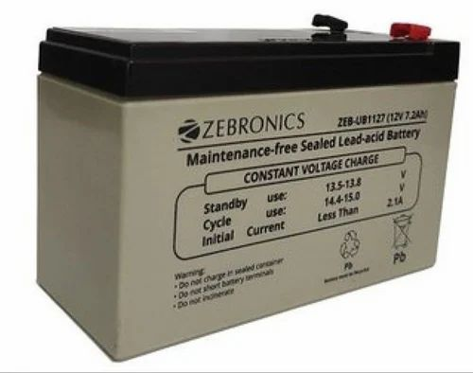

Figure 5.1 LEAD-ACID Battery

Sealed/Maintenance–Free The valve regulated spill proof construction allows trouble-free safe operation in any position. There is no need to add electrolyte, as gases generated during the charge phase are recombined in a unique “oxygen cycle”. Power-Sonic sealed lead acid batteries can be operated in virtually any orientation without the loss of capacity or electrolyte leakage. However, upside down operation is not recommended.
Long Shelf Life A low self-discharge rate, up to approximately 3% per month, may allow storage of fully charged batteries for up to a year, depending on storage temperatures, before charging becomes critical. However, we strongly recommend that all batteries should be recharged within six months of receipt as it will enhance their long term life. Please refer to this Technical Manual and individual battery specification sheets for more details.

Design Flexibility Same model batteries may be used in series and/or parallel to obtain choice of voltage and capacity. The same battery may be used in either cyclic or standby applications. Over 80 models available to choose from.
Deep Discharge Recovery Special separators, advanced plate composition and a carefully balanced electrolyte system ensure that the battery has the ability to recover from excessively deep discharge.

Economical The high watt-hour per dollar value is made possible by the materials used in a sealed lead-acid battery; they are readily available and low in cost. Easy Handling No special handling precautions or shipping containers, surface or air, are required due to the leak-proof construction. Please refer to the declaration of non restricted status for D.O.T. and I.A.T.A. as listed in the Literature section

Compact Power-Sonic batteries utilize state of the art design, high grade materials, and a carefully controlled plate-making process to provide excellent output per cell. The high energy density results in superior power/volume and power/weight ratios. Low Pressure Valve Regulators All batteries feature a series of low pressure one-way relief valves. These valves safely release any excessive accumulation of gas inside the battery and then reseal. High Discharge Rate Low internal resistance allows discharge currents of up to ten times the rated capacity of the battery. Relatively small batteries may thus be specified in applications requiring high peak currents.
Wide Operating Temperature Range Power-Sonic batteries may be discharged over a temperature range of -40°C to +60°C (-40°F to + 140°F) and charged at temperatures ranging from -20°C to +50°C (-4°F to +122°F). Rugged Construction The high impact resistant battery case is made of nonconductive ABS plastic. The case materials impart great resistance to shock, vibration, chemicals and heat. Flame Retardant (FR) battery cases and lids are available where the end application dictates. Long Service Life PS/PSH and PSG Series: Have a design life of up to five years in standby applications. In cyclical applications up to 1,000 charge/discharge cycles can be expected depending on average depth of discharge.

Deep Discharge

- Power-Sonic batteries are protected against cell shorting by the addition of a buffering agent that ensures the presence of acid ions even in a fully discharged state.
- Power-Sonic defines “deep discharge” as one that allows the battery voltage under load to go below the cut-off (or “final”) voltage of a full discharge. The recommended cutoff voltage varies with the discharge rate. Table 1 shows the
- final discharge voltages per cell.
- It is important to note that deep discharging a battery at high rates for short periods is not nearly as severe as discharging a battery at low rates for long periods of time.
To clarify, let’s analyze two examples:

Battery A – Discharged at the 1C rate to zero volts.
“C” for a 4 AH battery, for example, is 4 amps. Full discharge is reached after about 30 minutes when
the battery voltage drops to 1.5V/cell. At this point, only 50% of rated capacity has been discharged (1C amps x 0.5 hrs = 0.5C Amp. Hrs). Continuing the discharge to zero volts will bring the total amount of
discharged ampere-hours to approximately 75% because the rapidly declining voltage quickly reduces current flow to a trickle. The battery will recover easily from this type of deep discharge.
- Battery B – Discharged at the 0.01 C rate to zero volts.0.0IC for a 4 AH battery is 40mA. Full discharge is reached after 100+ hours when the
- terminal voltage drops to 1.75 V/cell. At this point, the battery has already delivered 100% of its rated capacity (0.01 x100 hrs = 1C Amp. Hrs.).
- Continuing the discharge to zero volts will keep the battery under load for afurther period of time, squeezing out every bit of stored energy.

This type of “deep” discharge is severe and is likely to damage the battery. The sooner a severely
discharged battery is recharged, the better its chances to fully recover.

5.2.3 POWER SUPPLY MODULE
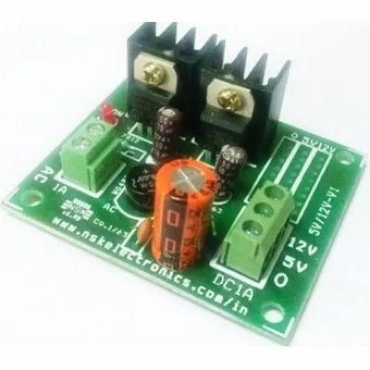
Figure 5.2 5V/12V DC Power supply module

sage/Application | Electronic Instruments
Output Voltage | 5-12 V DC
Input Voltage | 110-240 V
Rated Power | 32 kW
Maximum Load | 0.75 Amp

5.2.4 RECTIFIER:
The Rectifier circuit is used to convert the AC voltage into its corresponding DC voltage Rectifier having three types,
- Half wave rectifier.
- Full wave rectifier
- Bridge rectifier
The most important and simple device used in Rectifier circuit is the diode. This project used to bridge rectifier.A bridge rectifier makes use of four diodes in a bridge arrangement to achieve full-wave rectification. This is a widely used configuration, both with individual diodes wired as shown and with single component bridges where the diode bridge is wired internally. below diagram is bridge rectifier
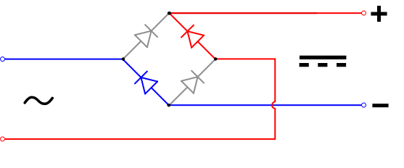
Figure 5.3 Rectifier

The simple function of the diode is to conduct when forward biased and not to conduct in reverse bias. The Forward Bias is achieved by connecting the diode’s positive with positive of the battery and negative with battery’s negative. The efficient circuit used is the Full wave Bridge rectifier circuit. The output voltage of the rectifier is in rippled form, the ripples from the obtained DC voltage are removed using other circuits available. The circuit used for removing the ripples is called Filter circuit.
The simple capacitor filter is the most basic type of power supply filter. The application of the simple capacitor filter is very limited. It is sometimes used on extremely high-voltage, low-current power supplies for cathode-ray and similar electron tubes, which require very little load current from the supply. The capacitor filter is also used where the power-supply ripple frequency is not critical; this frequency can be relatively high. The capacitor (C1) shown in figure 4-15 is a simple filter connected across the output of the rectifier in parallel with the load.
Capacitors are used as filter. The ripples from the DC voltage are removed and pure DC voltage is obtained. And also these capacitors are used to reduce the harmonics of the input voltage. The primary action performed by capacitor is charging and discharging. It charges in positive half cycle of the AC voltage and it will discharge in negative half cycle. Here we used 1000µF capacitor. So it allows only AC voltage and does not allow the DC voltage. This filter is fixed before the regulator. Thus the output is free from ripples.
The simple capacitor filter is the most basic type of power supply filter. The application of the simple capacitor filter is very limited. It is sometimes used on extremely high-voltage, low-current power supplies for cathode-ray and similar electron tubes, which require very little load current from the supply. The capacitor filter is also used where the power-supply ripple frequency is not critical; this frequency can be relatively high. The capacitor (C1) shown in figure 4-15 is a simple filter connected across the output of the rectifier in parallel with the load.
Capacitors are used as filter. The ripples from the DC voltage are removed and pure DC voltage is obtained. And also these capacitors are used to reduce the harmonics of the input voltage. The primary action performed by capacitor is charging and discharging. It charges in positive half cycle of the AC voltage and it will discharge in negative half cycle. Here we used 1000µF capacitor. So it allows only AC voltage and does not allow the DC voltage. This filter is fixed before the regulator. Thus the output is free from ripples.

5.2.5 RELAY
Additionally, a relay can also be used in conjunction with other sensors and modules to provide additional control and automation capabilities. For example, the relay can be used with a temperature sensor to control a heating or cooling system, or with a motion sensor to activate lights or alarms when motion is detected.
Moreover, the use of a relay can also enhance safety by isolating the low-power control circuit from the high-power circuit that is being switched. This can help prevent electrical shocks or damage to the control circuit in case of a fault or overload in the high-power circuit.
Overall, the use of a relay in an intelligent glove for visually impaired people can provide a versatile and efficient way of controlling electrical devices and systems, improving the user's independence and quality of life.
This is a LOW Level 5V 1-channel relay interface board, needs a 15-20mA driver current. It can be used to control various appliances and equipment with large current. It is equipped with high-current relays that work under AC250V 10A or DC30V 10A. It has a standard interface that can be controlled directly by microcontroller. This module is optically isolated from high voltage side for safety requirement and also prevent ground loop when interface to microcontroller.
Operating Voltage:
- Relay Maximum output: DC 30V/10A, AC 250V/10A.
- 1 Channel Relay Module with Opto-coupler. LOW Level Trigger expansion board, which is compatible with Arduino control board.
- Standard interface that can be controlled directly by microcontroller (8051, AVR, *PIC, DSP, ARM, ARM, MSP430, TTL logic).
- Relay of high quality low noise relays SPDT. A common terminal, a normally open, one normally closed terminal.
- Opto-Coupler isolation, for high voltage safety and prevent ground loop with microcontroller.

VCC and RY-VCC are also the power supply of the relay module. When you need to drive a large power load, you can take the jumper cap off and connect an extra power to RY-VCC to supply the relay; connect VCC to 5V of the MCU board to supply input signals.
NOTES: If you want complete optical isolation, connect "Vcc" to Arduino +5 volts but do NOT connect Arduino Ground. Remove the Vcc to JD-Vcc jumper. Connect a separate +5 supply to "JD-Vcc" and board Gnd. This will supply power to the transistor drivers and relay coils.
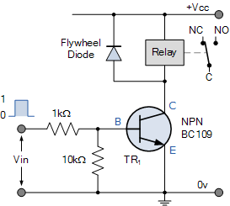
If relay isolation is enough for your application, connect Arduino +5 and Gnd, and leave Vcc to JD-Vcc jumper in place.

Figure 5.4 Relay circuit diagram

In a Battery Management System (BMS), a 12V relay functions as a protective and control component that regulates the connection between the battery pack and external circuits such as chargers or loads. When the BMS detects that all battery conditions—such as voltage, temperature, and current—are within safe operating ranges, it sends a 12V signal to energize the relay coil. This creates a magnetic field that pulls a switch contact closed, allowing current to flow from the battery to the load or charger. If the BMS detects any unsafe conditions, such as overcharging, under-voltage, overcurrent, or excessive heat, it immediately

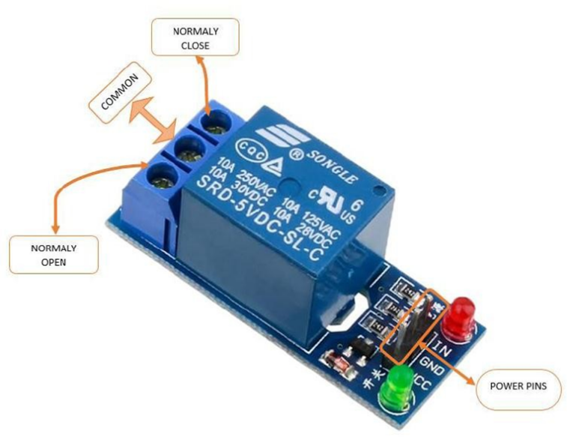
Figure 5.5 Relay controlled switch

Operating Principle:
See the picture below: A is an electromagnet, B armature, C spring, D moving contact, and E fixed contacts. There are two fixed contacts, a normally closed one and a normally open one. When the coil is not energized, the normally open contact is the one that is off, while the normally closed one is the other that is on.
Supply voltage to the coil and some currents will pass through the coil thus generating the electromagnetic effect. So the armature overcomes the tension of the spring and is attracted to the core, thus closing the moving contact of the armature and the normally open (NO) contact or you may say releasing the former and the normally closed (NC) contact. After the coil is de-energized, the electromagnetic force disappears and the armature moves back to the original position, releasing the moving contact and normally closed contact. The closing and releasing of the contacts results in power on and off of the circuit.

Input:
VCC : Connected to positive supply voltage (supply power according to relay voltage) GND Connected to supply ground.
Output:
Each module of the relay has one NC (normally close), one NO (normally open) and one COM (Common) terminal. So there are 2 NC, 2 NO and 2 COM of the channel relay in total. NC stands for the normal close port contact and the state without power. NO stands for the normal open port contact and the state with power. COM means the common port. You can choose NC port or NO port according to whether power or not.
Testing Setup:
When a low level is supplied to signal terminal of the 2-channel relay, the LED at the output terminal will light up. Otherwise, it will turn off. If a periodic high and low level is supplied to the signal terminal, you can see the LED will cycle between on and off.
For Arduino： Step 1：
Connect the signal terminal IN1、IN2 of 2-channel relay to digital pin 4 & 5 of the Arduino Uno or ATMega2560 board, and connect an LED at the output terminal.
IN1> 4
IN2> 5
Step 2:
Upload the sketch "text code" to the Arduino Uno or ATMega2560 board. Then you can see the LED cycle between on and off.
5.2.6 VOLTAGE SENSOR
Voltage sensors are wireless tools that can be attached to any number of assets, machinery or equipment. They provide 24/7 monitoring, constantly watching for voltage data that could indicate a problem. Low voltage may signal a potential issue, while other assets may be in danger when voltage is too high. When thresholds are exceeded, alerts are immediately sent to a centralized computer system.
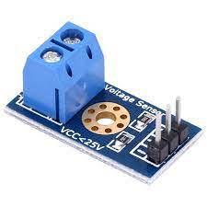
Figure 5.6 Voltage Sensor

5.2.7 CURRENT SENSOR
Current sensors are either open- or closed-loop. Open-loop current sensors measure AC and DC currents and provide electrical isolation between the circuit being measured and the output of the sensor (the primary current is measured without electrical contact with the primary circuit, providing galvanic isolation). Less expensive than their closed-loop cousins, open-loop current sensors are generally preferred in battery-powered circuits given their low-operating power requirements and small footprint features.

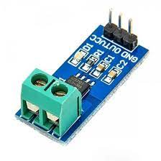
Figure 5.7 Current Sensor
Closed-loop sensors measure AC and DC currents and provide electrical isolation. They offer fast response, high linearity, and low temperature drift. The current output of the closed-loop sensor is relatively immune to electrical noise. The Closed- Loop sensor is sometimes called a ‘Zero-Flux’ sensor because its Hall-Effect sensor feeds back an opposing current into a secondary coil, wound on the magnetic core to zero the flux produced in the magnetic core by the primary current. Closed-loop sensors are often the sensor of choice when high accuracy is essential.

Open loop current sensors consist of a Hall sensor mounted in the air gap of a magnetic core. A conductor produces a magnetic field comparable to the current. The magnetic field is concentrated by the core and measured by the Hall sensor. The signal from the Hall generator is low, so it is amplified, and it is this amplified signal that becomes the sensor’s output. Open-loop sensors normally have circuitry that provides temperature compensation and calibrated high-level voltage output. While they have a definite price advantage over closed-loop counterparts, their downside is that they can be prone to saturation and temperature drift. The drift can be minimized to some extent, however, by injecting a positive coefficient in the control current to reduce the drift in sensitivity over temperature.

5.2.8 DHT11
DHT11 Temperature & Humidity Sensor features a temperature & humidity sensor complex with a calibrated digital signal output. By using the exclusive digital-signal-acquisition technique and temperature & humidity sensing technology, it ensures high reliability and excellent long-term stability. This sensor includes a resistive-type humidity measurement component and an NTC temperature measurement component, and connects to a high performance 8-bit microcontroller, offering excellent quality, fast response, anti-interference ability and cost-effectiveness.
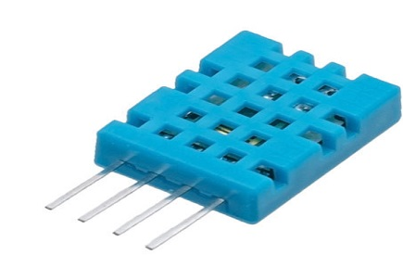
Figure 5.8 DHT11 Temperature & Humidity Sensor
Each DHT11 element is strictly calibrated in the laboratory that is extremely accurate on humidity calibration. The calibration coefficients are stored as programmes in the OTP memory, which are used by the sensor’s internal signal detecting process. The single-wire serial interface makes system integration quick and easy. Its small size, low power consumption and up-to-20 meter signal transmission making it the best choice for various applications, including those most demanding ones. The component is 4-pin single row pin package. It is convenient to connect and special packages can be provided according to users’ request
power-on LED. DHT11 is a relative humidity sensor. To measure the surrounding air this sensor uses a thermistor and a capacitive humidity sensor.
DHT11 is small in size with operating voltage from 3 to 5 volts. The maximum current used while measuring is 2.5mA.

DHT11 Module Pinout
The DHT11 module has a total of 3 pins. In which two are for power and one is for communication. The pinout of a DHT11 Sensor module is as follows:

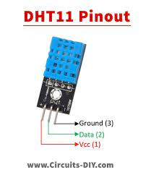
Figure 5.9 DHT11 Pinout
5.2.9 BUZZER
The buzzer is a sounding device that can convert audio signals into sound signals. It is usually powered by DC voltage. It is widely used in alarms, computers, printers and other electronic products as sound devices. It is mainly divided into piezoelectric buzzer and electromagnetic buzzer, represented by the letter "H" or "HA" in the circuit. According to different designs and uses, the buzzer can emit various sounds such as music, siren, buzzer, alarm, and electric bell.
A buzzer or piezo speaker is an audio signaling device commonly used to produce sound. Piezo buzzer produces sound based on the reverse principle of the piezoelectric effect. The buzzer is a less costly and light-weighted electronic device that’s why it is used in computers, alarm devices, refrigerators, microwave ovens, security devices, and so on
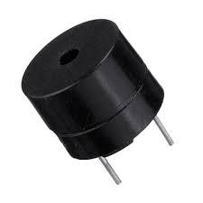
Figure 5.10 Buzzer
There are two conductors available inside the buzzer along with a piezo crystal between them. Whenever the potential is applied across the crystal than the conductor’s position gets changed due to which 2 to 4 kHz sound wave produced by the buzzer.
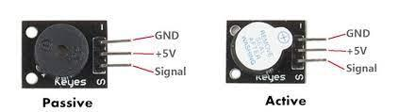

Figure 5.11 Passive and Active Buzzer Module
There are two types of piezoelectric buzzers that are commonly used in electronics projects – active buzzers and passive buzzers. Active buzzers are called active because they only need a DC voltage to produce sound. Passive buzzers need an AC voltage to produce sound.

5.2.10 COOLING SYSTEM
DC FAN
Temperature controlling is required in many places such as server rooms, houses, industries, etc. So this project can be very useful in understanding the basics, how you can control the temperature at your home. You can take this as a DIY project which can be used anywhere. Here the Temperature controlled fan will act to the temperature changes.
We have also written a blog on what temperature sensors are, if you are interested feel free to read that as well to understand more about these types of sensors.
We are going to do this with a DHT11 temperature and humidity sensor. It can be done in various other ways as well. With a thermistor or other sensors like a contactless temperature sensor. But thermistor usually needs contact of the surface and contactless sensors can be costly. While DHT11 is a cost-effective sensor.
In this article, we are going to discuss making a temperature-controlled fan using Arduino. With this circuit, we will be able to change the fan speed in our home or any place according to the room temperature and also display the temperature and fan speed changes on a 16x2 LCD display. To do this we will be using an ESP32 Board, LCD, DHT11 sensor Module, and DC fan. Let's get started.
Upon implementation and testing, the Electric Vehicle Monitoring System (EVMS) demonstrated promising results in enhancing the safety, reliability, and performance of electric vehicles. Real-time monitoring capabilities enabled proactive maintenance, allowing for timely intervention in response to fluctuations in battery voltage, current, and temperature. Integration with the Thing Speak IoT platform facilitated remote accessibility, empowering users to monitor vehicle data and perform diagnostics from anywhere with internet connectivity.

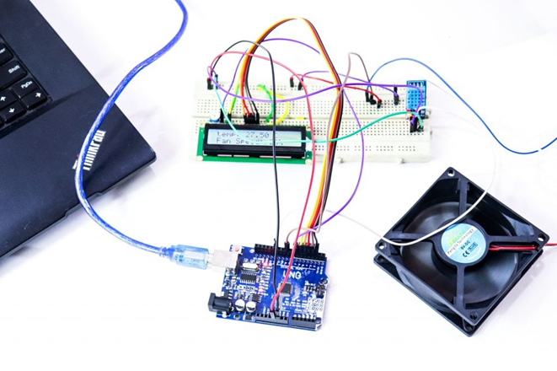
Figure 5.12 Cooling System

The incorporation of intelligent temperature control mechanisms proved effective in mitigating overheating risks, as evidenced by the timely activation of cooling fans and audible alerts (buzzer) when battery temperatures exceeded predefined thresholds. This proactive approach not only safeguarded the integrity of the battery system but also contributed to overall vehicle safety.
Furthermore, the EVMS exhibited cost-effectiveness and scalability, leveraging readily available components and open-source software to offer an accessible monitoring solution for electric vehicles of varying scales. The system's user-friendly interface and ease of deployment make it suitable for both consumers and manufacturers, facilitating widespread adoption and integration into existing electric vehicle fleets.
In conclusion, the results obtained from the implementation and testing of the EVMS underscore its potential to address the challenges faced by existing monitoring systems while promoting the adoption and advancement of sustainable transportation through enhanced safety, reliability, and efficiency in electric vehicles.

5.2.11 WIFI MODULE ESP 01
The ESP32 ESP-01 is a Wi-Fi module that allows microcontrollers access to a Wi-Fi network. This module is a self-contained SOC (System On a Chip) that doesn’t necessarily need a microcontroller to manipulate inputs and outputs as you would normally do with an Arduino, for example, because the ESP-01 acts as a small computer. Depending on the version of the ESP32, it is possible to have up to 9 GPIOs. Thus, we can give a microcontroller internet access like the Wi-Fi shield does to the Arduino, or we can simply program the ESP32 to not only have access to a Wi-Fi network, but to act as a microcontroller as well.
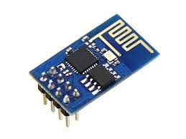
Figure 5.13 ESP-01
The ESP32 ESP-01 module has three operation modes:
- Access Point (AP)
- Station (STA)
- Both
In AP the Wi-Fi module acts as a Wi-Fi network, or access point (hence the name), allowing other devices to connect to it. This does not mean that you will be able to check your Facebook from your device while the ESP-01 module is operating in the AP mode. It simply establishes a two way communication between the ESP32 and the device that is connected to it via Wi-Fi.
In STA mode, the ESP-01 can connect to an AP such as the Wi-Fi network from your house. This allows any device connected to that network to communicate with the module.
The third mode of operation permits the module to act as both an AP and a STA.

Working
The ESP32 can be controlled from your local Wi-Fi network or from the internet (after port forwarding). The ESP-01 module has GPIO pins that can be programmed to turn an LED or a relay ON/OFF through the internet. The module can be programmed using an Arduino/USB-to TTL converter through the serial pins (RX, TX)

5.2.12 BLYNK
Blynk is a comprehensive software suite that enables the prototyping, deployment, and remote management of connected electronic devices at any scale.
Whether it's personal IoT projects or commercial connected products in the millions, Blynk empowers users to connect their hardware to the cloud and create IOS, Android, and web applications, manalyze real-time and historical data from devices, remotely control them from anywhere, receive important notifications, and much more.
Blynk App
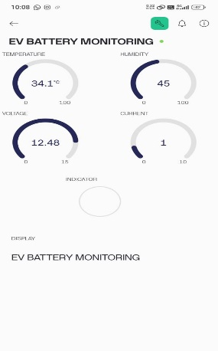
Figure 5.14 Blynk App
Blynk Apps is a versatile native iOS and Android mobile application that serves these major functions:
- Remote monitoring and control of connected devices that work with Blynk platform.
- Configuration of mobile UI during prototyping and production stages.
- Automation of connected device operations.
Applications made with Blynk are ready for the end-users. Whether they are family members, employees, or product purchasers, they can easily download the app, connect their devices, and start using them.
Blynk also offers a white-label solution as part of the Business Plan, allowing you to customize the app with your company logo, app icon, theme, colors, and publish it on App Store and Google Play under your company's name. These customized apps will work seamlessly with your devices.
Blynk. Edgeent
Blynk. Edgent is a packaged solution designed to simplify the connection of supported devices to the Blynk platform, providing access to all its advanced features without extensive coding.
Blynk Library
Blynk Library is a user-friendly and portable C++ library, that comes pre-configured to work with hundreds of development boards. It implements a streaming connection protocol, allowing for low-latency and bi-directional communication.
Blynk Cloud
Blynk. Cloud is a server infrastructure acting as the heart of Blynk IoT platform binding all the components together.
Blynk also offers private servers. Blynk is a multi-tenant solution that allows you to configure user access to devices and data by defining roles and permissions.

CHAPTER 6

6.1 RESULT
SOURCE CODE
#include <Wire.h>
#include <LiquidCrystal_I2C.h>
LiquidCrystal_I2C lcd(0x27,16,2);
#define BLYNK_TEMPLATE_ID "TMPL3C0JH-GAa"
#define BLYNK_TEMPLATE_NAME "EV BATTERY MONITORING"
#define BLYNK_AUTH_TOKEN "J78YQDlj93odG1OEuyfwj8O4c5J6HrvT"
#include <WiFi.h>
#include <BlynkSimpleEsp32.h>
char auth[] = BLYNK_AUTH_TOKEN;
char ssid[] = "iot12345"; // Replace with your WiFi SSID
char pass[] = "iot12345"; // Replace with your WiFi password
#include "ACS712.h"
ACS712 currentSensor(ACS712_20A, 32);
//#include <Wire.h>
#include "DHT.h"
#define DHTPIN 25 // CHANGE PIN NUM
#define DHTTYPE DHT11
DHT dht(DHTPIN, DHTTYPE);
#define BUZ 15
#define FAN 26
float Vin_1 = 0.0;
float R1 = 30000.0; //
float R2 = 7500.0; //
int value_1 = 0;
int val=0;
float h;
float t;
void setup()
{
Serial.begin(9600);
dht.begin();
lcd.begin(); // initialize the lcd
lcd.begin();
lcd.backlight();
lcd.setCursor(0,0);
lcd.print("BAT..MANANGMENT");
lcd.setCursor(0,1);
lcd.print("SYSTEM FOR EV");
pinMode(BUZ,OUTPUT);
digitalWrite(BUZ,LOW);
pinMode(FAN ,OUTPUT);
digitalWrite(FAN ,LOW);
delay(3000);
lcd.clear();
currentSensor.calibrate();
Blynk.begin(auth, ssid, pass, "blynk.cloud", 80);
}
void loop()
{
Blynk.run();
Blynk.virtualWrite(V4, 0);
Blynk.virtualWrite(V5, "EV BATTERY MONITORING");
digitalWrite(FAN ,LOW);
digitalWrite(BUZ,LOW);
VoltageSensor_1();
current_sensor();
delay(2000);
lcd.clear();
Temp();
delay(2000);
lcd.clear();
if(t>=40)
{
lcd.clear();
lcd.setCursor(0,0);
lcd.print("EMERGENCY");
Blynk.virtualWrite(V4, 1);
Blynk.virtualWrite(V5, "EMERGENCY");
delay(2000);
lcd.clear();
digitalWrite(FAN,HIGH);
digitalWrite(BUZ,HIGH);
while(t>40)
{
Serial.println("loop2");
Blynk.virtualWrite(V4, 1);
Blynk.virtualWrite(V5, "EMERGENCY");
Temp();
delay(1000);
lcd.clear();
lcd.setCursor(0,0);
lcd.print("EMERGENCY");
delay(1000);
lcd.clear();
}

}
if((t>=37)&&(t<40))
{
lcd.clear();
digitalWrite(FAN,HIGH);
Serial.println("FAN ON");
digitalWrite(BUZ,HIGH);
Serial.println("loop");
lcd.setCursor(0,1);
lcd.print("WARNING LIMIT");
Blynk.virtualWrite(V4, 1);
Blynk.virtualWrite(V5, "WARNING");
delay(3000);
lcd.clear();
while((t>=37)&&(t<=40))
{
Serial.println("loop1");
digitalWrite(FAN,HIGH);
Blynk.virtualWrite(V4, 1);
Blynk.virtualWrite(V5, "WARNING");
Temp();
delay(1000);
lcd.clear();
lcd.setCursor(0,0);
lcd.print("WARNING.....");
delay(1000);
lcd.clear();
}
}
if(t<35)
{
Blynk.virtualWrite(V4, 0);
Blynk.virtualWrite(V5, "EV BATTERY MONITORING");
digitalWrite(FAN,LOW);
Serial.println("FAN OFF");
digitalWrite(BUZ,LOW);
}
}
void Temp()
{
Serial.print("DHT IN");
//lcd.clear();
h = dht.readHumidity();
h= (h+15);
t = dht.readTemperature();
t = (t-10);
if (isnan(t) || isnan(h)) { // checking sensor #2
Serial.print("DHT11 SENSOR 1 ERROR");// print error message
}
Serial.print(F("Humidity: "));
Serial.print(h);
Serial.print(F("% Temperature: "));
Serial.print(t);
Blynk.virtualWrite(V0, t);
Blynk.virtualWrite(V1, h);
lcd.setCursor(0,0);
lcd.print("TEMP: ");
lcd.print(t);
lcd.setCursor(0,1);
lcd.print("HUM: ");
lcd.print(h);
}
void VoltageSensor_1(){
value_1 = analogRead(33);
float a=value_1*5.0;
float VOut_1=a/1024.0;
Vin_1 = VOut_1 / (R2/(R1+R2));
Vin_1=(Vin_1/6);
lcd.setCursor(0,0);
lcd.print("V:");
6.2 HARDWARE OUTPUT:

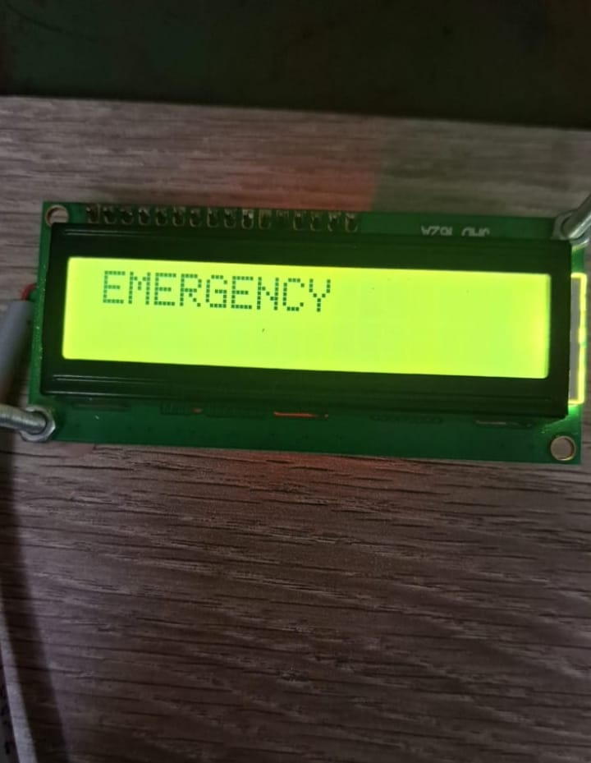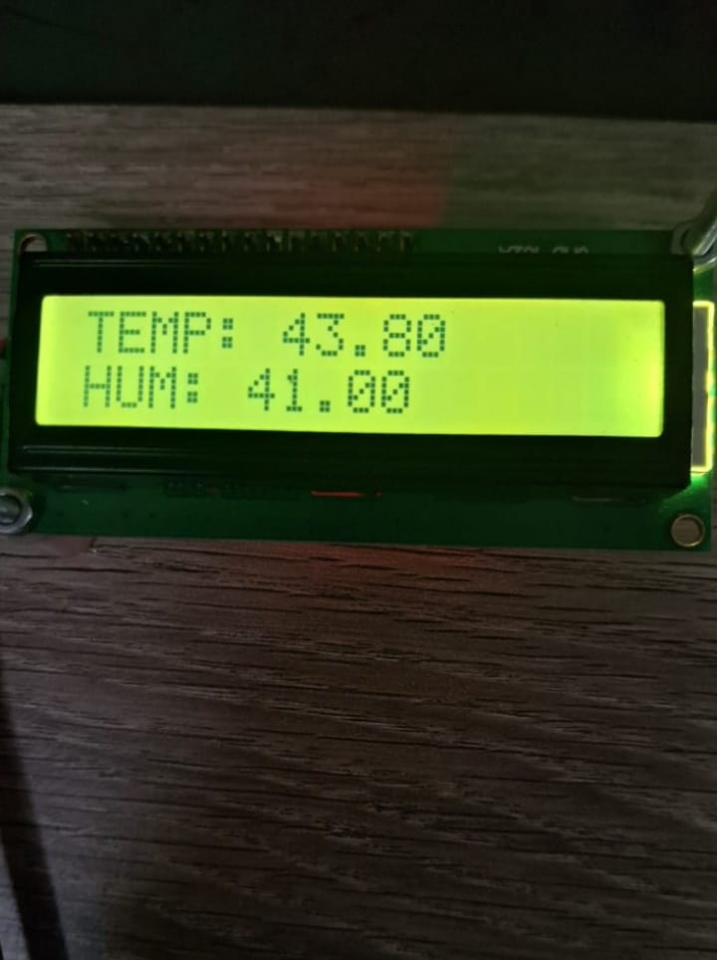

Figure 6.1 Hardware output

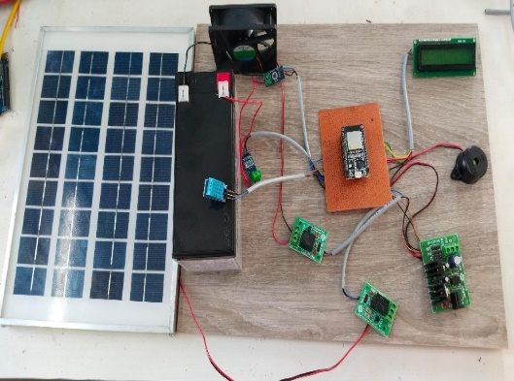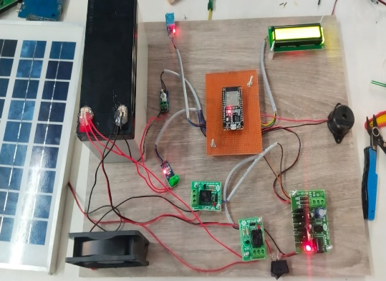
Figure 6.2 Hardware kit

6.3 SOFTWARE OUTPUT:

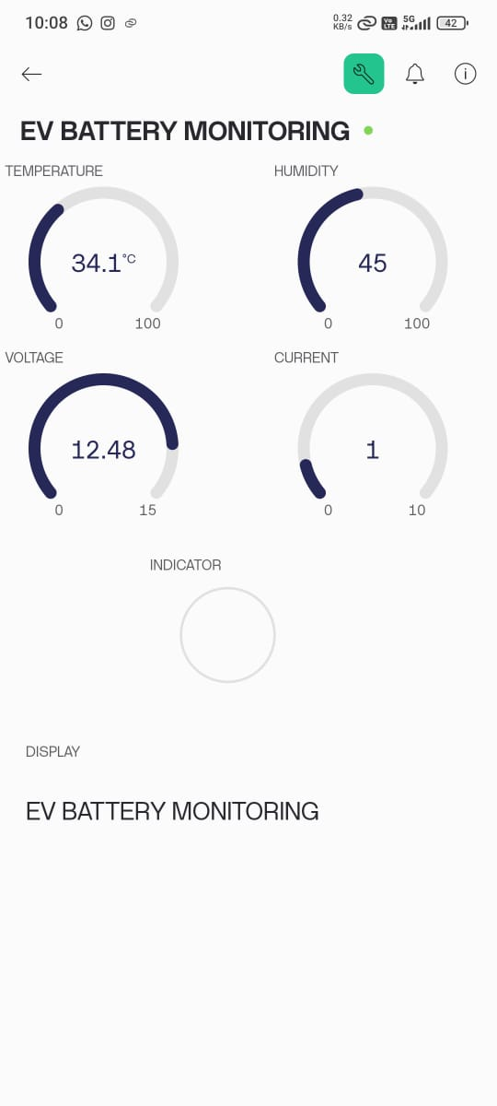
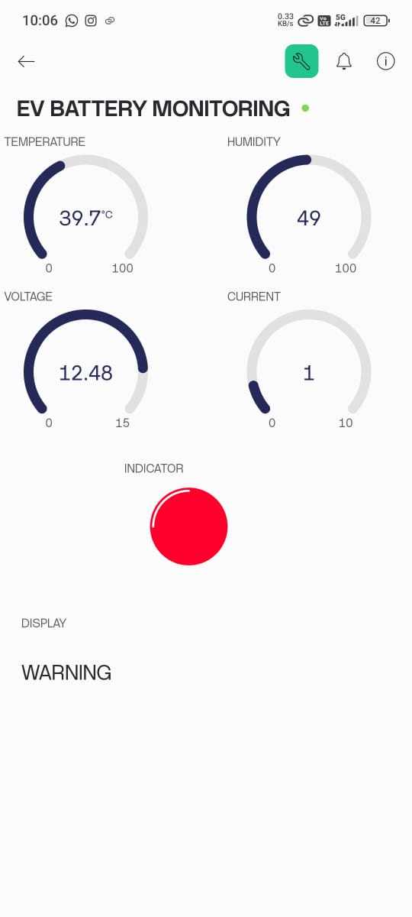

Figure 6.3 Software output

APPLICATIONS
- It is used in EVs to monitor battery voltage, current, and temperature in real-time to prevent failures and enhance performance.
- It enables centralized monitoring of multiple EVs using Blynk or Blynk platforms, improving maintenance and operational efficiency.
- It supports intelligent transport systems by integrating IoT-based battery monitoring into electric buses and taxis.
- It monitors battery conditions before and after charging to ensure battery safety and efficient charging cycles.
- It helps vehicle owners or service centers detect abnormalities early through cloud-based data monitoring.
- It acts as a hands-on learning tool for students studying IoT, embedded systems, and EV technologies.
- It is useful in research setups for testing and analyzing various battery chemistries under real-time load conditions.

CHAPTER 7

FUTURE SCOPE
- Integration of additional sensors for more comprehensive monitoring of parameters such as vibration, and current leakage.
- Implementation of predictive analytics to enable proactive maintenance and reduce downtime.
- Application of machine learning algorithms for intelligent fault detection, diagnosis, and system optimization.
- Improved interoperability with various electric vehicle architectures and compliance with emerging industry standards to ensure wide-scale adaptability.

CONCLUSION
The Electric Vehicle Monitoring System (EVMS) developed in this project effectively addresses the limitations of existing monitoring solutions by enhancing the safety, reliability, and performance of electric vehicles. Through the integration of real-time monitoring capabilities and remote access via the Blynk IoT platform, the system ensures constant surveillance of critical vehicle parameters. The implementation of proactive temperature control mechanisms and alert systems contributes significantly to battery protection and overall vehicle safety. The successful testing and validation of the EVMS highlight its potential as a practical and impactful solution in the growing electric vehicle industry.

REFERENCE
- Amarnath, M., Chitra, R., & Natarajan, V. (2020). Design and Development of an Electric Vehicle Monitoring System. International Journal of Advanced Trends in Computer Science and Engineering, 9(5), 6856-6862.
- Zhang, Y., Lin, Y., & Li, K. (2021). Design of Electric Vehicle Monitoring System Based on Internet of Things. 4th International Conference on Electric Vehicle Technology (ICEVT).
- Shrivastava, A., & Singh, P. (2020). Electric Vehicle Monitoring System. International Journal of Scientific & Technology Research, 9(8), 354-357.
- Zhang, C., Yuan, Z., & Hu, Z. (2020). Real-time Battery State-of-Charge Estimation for Electric Vehicles Based on Internet of Things. IEEE Internet of Things Journal, 7(10), 10165-10176.
- Zhao, Z., Han, S., & Zhou, M. (2019). Electric Vehicle Battery Management System Based on Internet of Things. Journal of Physics: Conference Series, 1321(5), 052002.
- Wang, S., Chen, Y., & Xie, L. (2018). Design of Remote Monitoring System for Electric Vehicle Based on IoT. IEEE Access, 6, 76958-76968.
- Chen, Y., Zhang, X., & Sun, Y. (2020). Research on Electric Vehicle Battery Monitoring System Based on IoT. 4th International Conference on Electrical and Information Technologies for Rail Transportation (EITRT).
- Lu, H., Wang, S., & He, Y. (2020). Design of Battery Management System for Electric Vehicle Based on Internet of Things. 3rd International Conference on Computer Science and Application Engineering (CSAE).
- Li, Z., Liu, Y., & Zhang, S. (2020). Research on Electric Vehicle Monitoring System Based on LoRa. 5th International Conference on Electrical Engineering, Control and Robotics (EECR).
- Liu, Y., Wang, J., & Li, J. (2019). Design of Electric Vehicle Monitoring System Based on IoT. International Conference on Smart Grid and Electrical Automation (ICSGEA).
- Zhang, H., Wang, Y., & Jiang, Y. (2019). Design of Electric Vehicle Battery Monitoring System Based on NB-IoT. 2nd International Conference on Electrical and Electronics Engineering (ICEEE).
- Chen, C., Zhu, L., & Zhang, Z. (2021). Real-Time Monitoring System for Electric Vehicle Battery Based on IoT. IEEE Transactions on Industrial Informatics, 17(4), 2683-2691.
- Li, X., Chen, L., & Wang, X. (2020). Research on Electric Vehicle State Monitoring System Based on IoT. International Conference on Electrical Engineering and Green Energy (CEEGE).
- Han, L., Wang, X., & Wang, Y. (2018). Design of Electric Vehicle Monitoring System Based on IoT. International Conference on Electrical Engineering and Control Technologies (ICEECT).
- Tang, J., Zhang, C., & Zuo, Y. (2019). Design and Implementation of Electric Vehicle Monitoring System Based on IoT. IEEE International Conference on Industrial Internet (ICII).
- Gao, J., Chen, C., & Xiang, S. (2020). Electric Vehicle Battery Monitoring System Based on Internet of Things. IEEE Access, 8, 149605-149613.
- Wang, X., Li, W., & Wang, Y. (2019). Research on Electric Vehicle Battery Monitoring System Based on IoT. 9th International Conference on Advanced Materials Research (ICAMR).
- Chen, Y., Li, X., & Guo, Z. (2021). Design and Implementation of Electric Vehicle Monitoring System Based on IoT. 8th International Conference on Automation, Control and Robotics (ICACR).
- Zhang, X., Zhang, S., & Wang, S. (2020). Development of Electric Vehicle Battery Monitoring System Based on IoT. 10th International Conference on Electrical and Electronics Engineering (ICEEE).
- Liu, J., Guo, J., & Huang, J. (2019). Design of Electric Vehicle Monitoring System Based on IoT Technology. International Conference on Electrical Engineering and Information Technology (ICEEIT).
- Li, X., Wang, Y., & Wang, X. (2020). Design of Real-Time Monitoring System for Electric Vehicle Battery Based on IoT. International Conference on Intelligent Transportation, Big Data & Smart City (ICITBS).
- Yang, S., Zhang, Q., & Chen, H. (2021). Design and Implementation of Electric Vehicle Monitoring System Based on LoRa and IoT. IEEE Transactions on Intelligent Transportation Systems, 22(4), 2077-2086.
- Zhang, Y., Wang, X., & Li, Z. (2020). Development of Electric Vehicle Battery Monitoring System Based on NB-IoT. 3rd International Conference on Internet of Things: Systems, Management and Security (IoTSMS).
- Liu, W., Zhang, Y., & Li, X. (2018). Research on Electric Vehicle Battery Monitoring System Based on ZigBee and IoT. International Conference on Internet of Things and Intelligent Applications (IoTIA).
- Wang, S., Wang, X., & Li, W. (2021). Design of Electric Vehicle Monitoring System Based on IoT and Blockchain. IEEE Transactions on Industrial Informatics, 17(8), 5685-5693.
- Chen, C., Liu, J., & Wang, Y. (2019). Development of Electric Vehicle Battery Monitoring System Based on IoT and Cloud Computing. 6th International Conference on Automation, Control and Robotics (ICACR).
- Zhang, H., Li, W., & Wang, X. (2020). Implementation of Electric Vehicle Monitoring System Based on IoT and Edge Computing. International Conference on Internet of Things, Big Data and Security (IoTBDS).
- Liu, J., Chen, Y., & Zhang, S. (2019). Research on Electric Vehicle Monitoring System Based on IoT and Wireless Sensor Networks. International Conference on Computer Engineering and Technology (ICCET).
- Wang, X., Zhang, Y., & Chen, C. (2018). Design and Implementation of Electric Vehicle Battery Monitoring System Based on IoT and Deep Learning. IEEE International Conference on Advanced Robotics and Mechatronics (ICARM).
- Yang, S., Zhang, Q., & Chen, H. (2020). Development of Electric Vehicle Monitoring System Based on IoT and Artificial Intelligence. International Conference on Artificial Intelligence and Internet of Things (AIIoT).
- Zhang, Y., Wang, X., & Li, Z. (2019). Research on Electric Vehicle Battery Monitoring System Based on IoT and Fog Computing. IEEE International Conference on Internet of Things (iThings).
- Wang, S., Wang, Y., & Zhang, H. (2021). Implementation of Electric Vehicle Monitoring System Based on IoT and Mobile Edge Computing. IEEE International Conference on Edge Computing (EdgeCom).
- Chen, C., Liu, J., & Wang, Y. (2020). Development of Electric Vehicle Battery Monitoring System Based on IoT and Blockchain. IEEE Transactions on Industrial Informatics, 16(9), 5868-5877.
- Zhang, H., Wang, X., & Li, Z. (2019). Design and Implementation of Electric Vehicle Monitoring System Based on IoT and Cloud-Fog Computing. International Conference on Cloud and Fog Computing (ICCF).
- Liu, W., Zhang, Y., & Li, X. (2020). Research on Electric Vehicle Battery Monitoring System Based on IoT and Reinforcement Learning. IEEE Transactions o
- n Industrial Informatics, 16(12), 7631-7

